**ECE-3502 IoT Domain Analyst LAB(L9+L10)**

**Name: Alpanshu Kataria**

**Reg. No.: 18BCE1267**

**Faculty: Maheshwari R**

Lab 4

**Task:**

Design a cloud based IoT based Healthcare application automation through FRED.

Create a patient registration registration form, after registration allow the patient from the client side will send the patient monitoring details.

Consider wearables like fitness bands such as blood pressure and heart rate, body temperature etc, I.e, symptoms and there present body status to the server , where the server wil send appropriate medical recommendations.

Using appropriate nodes frame the application and display the output in debug and UI>

**Flow:**

**For registration form:**

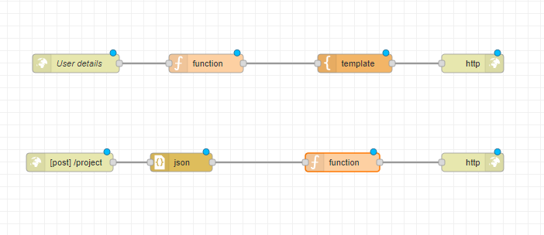

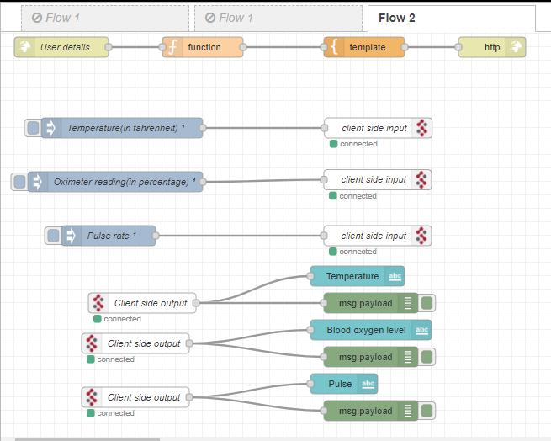**Client side for Health Monitoring System:**

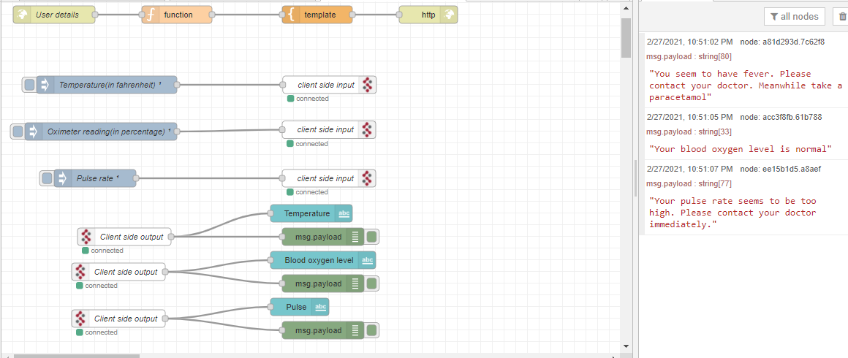

**Server side for Health Monitoring System:**

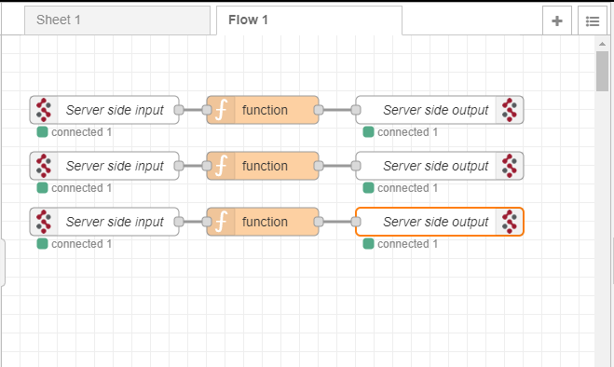

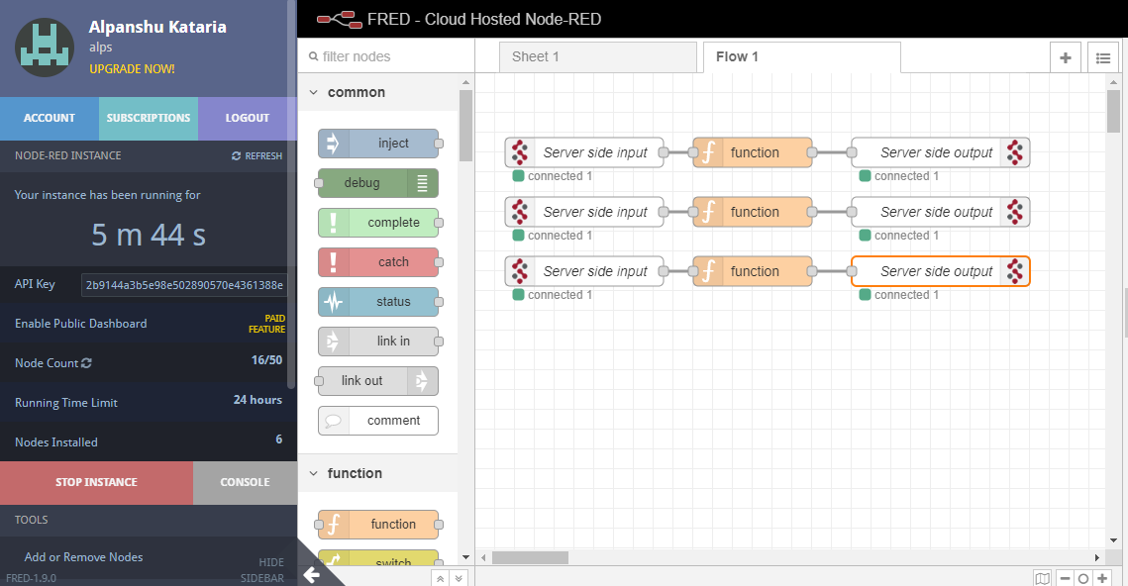

**Nodes:**

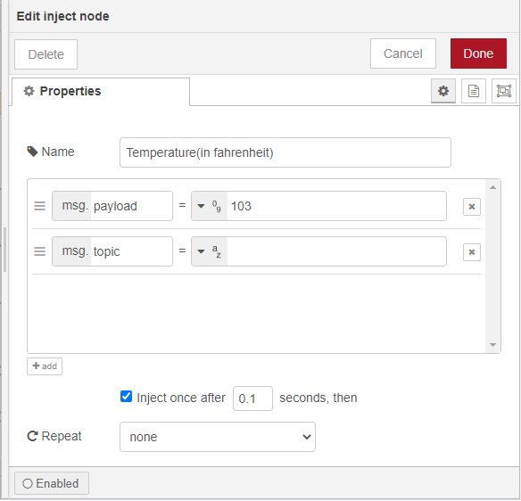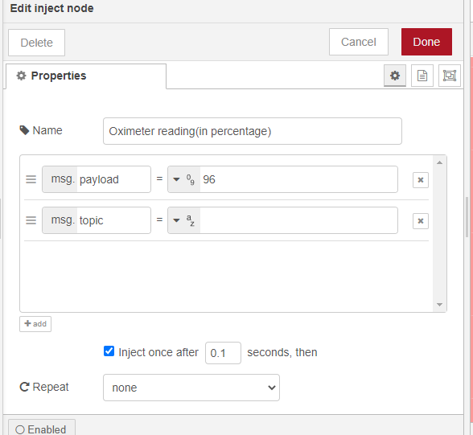

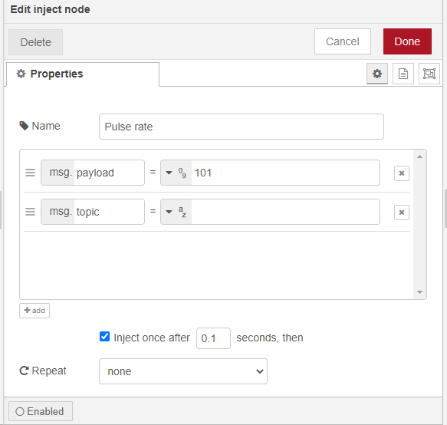

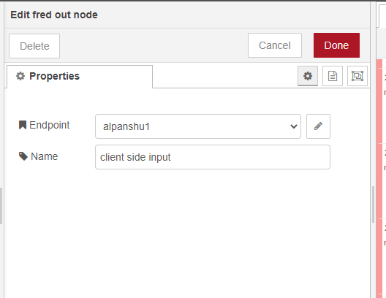

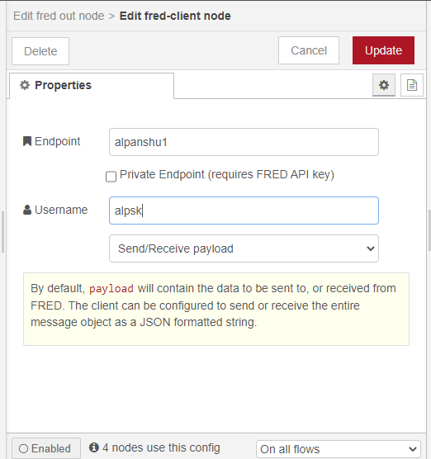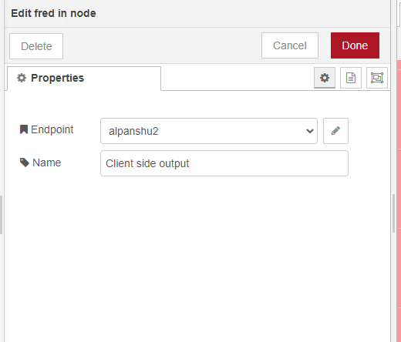

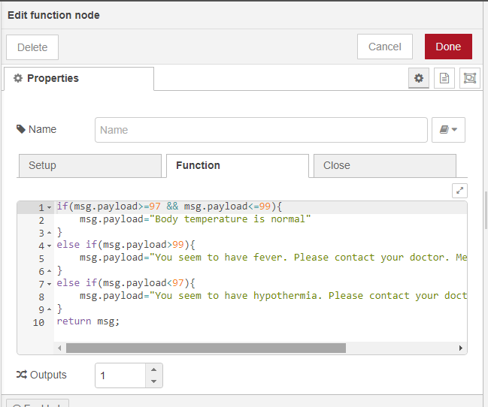

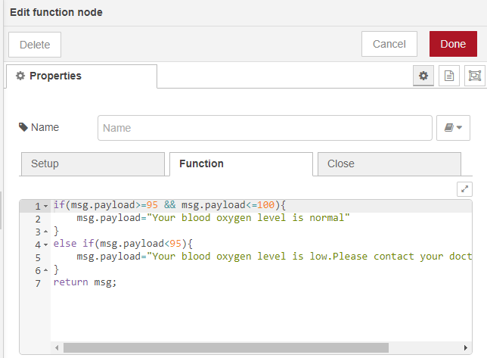

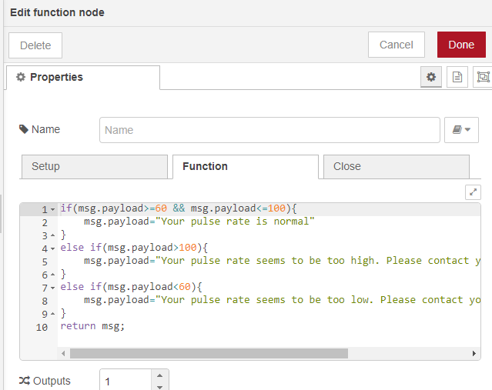

**HTML Code:**

<!DOCTYPE html>  
<html lang="en" >  
<head>  
<meta charset="UTF-8">  
<title>Registration Form</title>  
<meta name="viewport" content="width=device-width, initial-scale=1.0">  
<link rel="stylesheet" href="https://cdnjs.cloudflare.com/ajax/libs/normalize/5.0.0/normalize.min.css">  
<style>  
@import url(https://fonts.googleapis.com/css?family=Lato:300,400,700);  
 body {  
background-color: #e6e6e6;  
font-size: 100%;  
font-family: 'Lato', sans-serif;  
font-weight: 400;  
}  
div, textarea, input {  
-moz-box-sizing: border-box;  
-webkit-box-sizing: border-box;  
box-sizing: border-box;  
}  
.container {  
max-width: 510px;  
min-width: 324px;  
margin: 50px auto 0px;  
background-color: #fff;  
border: 1px solid #cfcfcf;  
border-bottom: 3px solid #ccc;  
}  
.row {  
width: 100%;  
margin: 0 0 1em 0;  
padding: 0 2.5em;  
}  
.row.header {  
padding: 1.5em 2.5em;  
border-bottom: 1px solid #ccc;  
background: url('https://www.cpajournal.com/wp-content/uploads/2019/02/GettyImages-1001713236-730x330.jpg') left -80px;  
color: #fff;  
}  
.row.body {  
padding: .5em 2.5em 1em;  
}  
.pull-right {  
float: right;  
}  
h1 {  
font-family: 'Lato', sans-serif;  
font-weight: 300;  
display: inline-block;  
font-weight: 100;  
 background-color: white;  
color: black;  
text-shadow: 2px 2px 5px red;  
font-size: 3.5em;  
border-bottom: 1px solid rgba(255, 255, 255, 0.3);  
margin: 0 0 0.1em 0;  
padding: 0 0 0.4em 0;  
}  
h3 {  
font-family: 'Lato', sans-serif;  
font-weight: 400;  
font-size: 1.25em;  
color: black;  
text-shadow: 2px 2px 5px red;  
margin: 1em 0 0.4em 0;  
}  
.btn {  
font-size: 1.0625em;  
display: inline-block;  
padding: 0.74em 1.5em;  
margin: 1.5em 0 0;  
color: #fff;  
border-width: 0 0 0 0;  
border-bottom: 5px solid;  
text-transform: uppercase;  
background-color: #b3b3b3;  
border-bottom-color: #8c8c8c;  
font-family: 'Lato', sans-serif;  
font-weight: 300;  
}  
.btn:hover {  
background-color: #bfbfbf;  
}  
.btn.btn-submit {  
background-color: #4f6fad;  
border-bottom-color: #374d78;  
}  
.btn.btn-submit:hover {  
background-color: #5f7db6;  
}  
form {  
max-width: 100%;  
 display: block;  
}  
form ul {  
margin: 0;  
padding: 0;  
list-style: none;  
}  
form ul li {  
margin: 0 0 0.25em 0;  
clear: both;  
display: inline-block;  
width: 100%;  
}  
form ul li:last-child {  
margin: 0;  
}  
form ul li p {  
margin: 0;  
padding: 0;  
float: left;  
}  
form ul li p.right {  
float: right;  
}  
form ul li .divider {  
margin: 0.5em 0 0.5em 0;  
border: 0;  
height: 1px;  
width: 100%;  
display: block;  
background-color: #4f6fad;  
background-image: linear-gradient(to right, #ee9cb4, #4f6fad);  
}  
form ul li .req {  
color: #ee9cb4;  
}  
form label {  
display: block;  
margin: 0 0 0.5em 0;  
color: #4f6fad;  
font-size: 1em;  
}  
 form input {  
margin: 0 0 0.5em 0;  
border: 1px solid #ccc;  
padding: 6px 10px;  
color: #555;  
font-size: 1em;  
}  
form textarea {  
border: 1px solid #ccc;  
padding: 6px 10px;  
width: 100%;  
color: #555;  
}  
form small {  
color: #4f6fad;  
margin: 0 0 0 0.5em;  
}  
@media only screen and (max-width: 480px) {  
.pull-right {  
float: none;  
}  
input {  
width: 100%;  
}  
label {  
width: 100%;  
display: inline-block;  
float: left;  
clear: both;  
}  
li, p {  
width: 100%;  
}  
input.btn {  
margin: 1.5em 0 0.5em;  
}  
h1 {  
font-size: 2.25em;  
}  
h3 {  
font-size: 1.125em;  
 }  
li small {  
display: none;  
}  
}  
</style>  
</head>  
<body>  
<!-- partial:index.partial.html -->  
<div class="container">  
<div class="row header">  
<h1>Registration Form &nbsp;</h1>  
<h3>Fill out the form below!</h3>  
</div>  
<div class="row body">  
<form method="post" action="/ui">  
<ul>  
<li>  
<p class="left">  
<label for="first_name">first name</label>  
<input type="text" name="first_name" placeholder="Alpanshu" />  
</p>  
<p class="pull-right">  
<label for="last_name">last name</label>  
<input type="text" name="last_name" placeholder="Kataria" />  
</p>  
</li>  
<li>  
<p>  
<label for="email">email <span class="req">*</span></label>  
<input type="email" name="email" placeholder="alpanshu.kataria@gmail.com" />  
</p>  
</li>  
<li>  
<p>  
<label for="Mob. No.">Mob. No.<span class="req">*</span></label>  
<input type="Mob. No." name="Mob. No." placeholder="Mob. No." />  
</p>  
</li>  
 <li>  
<p>  
<label for="Being diagnosed for:">Being diagnosed for:<span class="req">*</span></label>  
<input type="Being diagnosed for:" name="Being diagnosed for:" placeholder="Being diagnosed for:" />  
</p>  
</li>  
<li><div class="divider"></div></li>  
<li>  
<label for="Address">Address</label>  
<textarea cols="46" rows="3" name="Address"></textarea>  
</li>  
 <li>  
 <input class="btn btn-submit" type="submit" value="Submit" />  
 <small>or press <strong>enter</strong></small>  
 </li>  
</ul>  
</form>  
</div>  
</div>  
<!-- partial -->  
</body>  
</html>

**Debug monitor:**

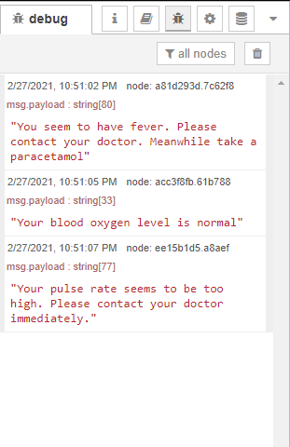

**Web Page for registration form:**

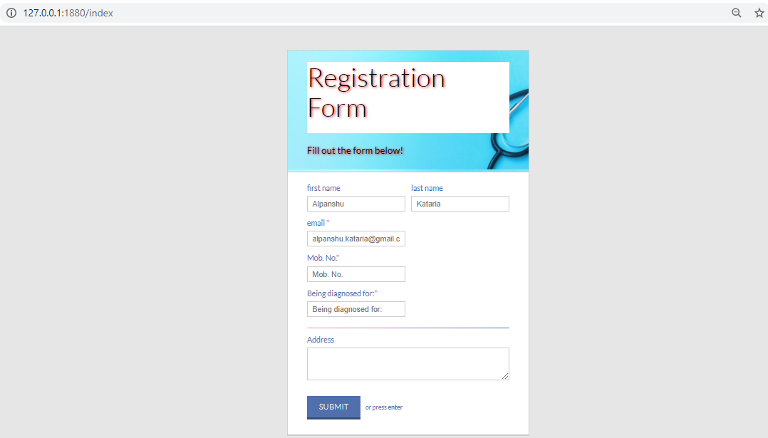

**Dashboard:**

